**Excess Property Notice**

**Excess Parcel at 10612 55th Ave S. (PMA 4522)**

**September 18, 2015**

TO: City of Seattle Departments and Other Public Agencies

FROM: Sabrina Buchanan, Department of Finance and Administrative Services (FAS)

SUBJECT: Excess Property

Excess PMS 4522 is a 12,942 sf vacant undeveloped lot which is zoned single family 7200 in Rainier Valley area. The Department of Finance and Administrative Services (FAS) has declared this property excess to the needs of the department. FAS’s initial recommendation is that the property be sold, and the sales proceeds will be deposited into the general fund.

In accordance with City of Seattle property disposition policies, this notice informs other City departments and public agencies of this property’s availability.

FAS manages the evaluation process for the reuse or disposal of City property. This is in accordance with City Council policies adopted under Resolution 29799 and amended by Resolution 30862.

*All departments and agencies are requested to return the* ***Excess Property Response Form****. In particular, please identify if your department has existing facilities, utilities, or property rights that affect the property. Please complete the* ***Excess Property Proposed Use Form*** *if your Department or agency is interested in acquiring the property for:*

|  |  |
| --- | --- |
| * Short-term use (less than six months) | * Potential City uses |
| * Permanent easements or covenants that will run with the land | * Other public agency use |

For questions regarding the City’s excess property disposition process, please contact Sabrina Buchanan at 206-615-1713 or at [sabrina.buchanan@seattle.gov](mailto:sabrina.buchanan@seattle.gov). **Please provide your comments and completed forms by October 16, 2015** to the following:

Sabrina Buchanan

Sabrina.buchanan@seattle.gov

Inter office mail

Sabrina Buchanan

Mail Stop SMT-52-01

US Mail

Sabrina Buchanan

City of Seattle - FAS

P.O. Box 94689

Seattle, Washington, 98124-4689

EXCESS PROPERTY DESCRIPTION

September 15, 2015

The Department of Finance and Administrative Services, as the Jurisdictional Department of this City owned property has identified the following information about this excess property.

**Property Name:** PMA 4522 located at 10612 55th Ave South

|  |  |  |  |  |  |  |
| --- | --- | --- | --- | --- | --- | --- |
| PMA | Building Size | Lot Size | Parcel # | Address | Zoning | 2015 Est. Value |
| 4522 | Undeveloped lot | 12,942 sf | 9368700111 | 10612 55th Ave South | SF 7200 | $65,000- $75,000 |
|  |  |  |  |  |  |  |

**Map:** 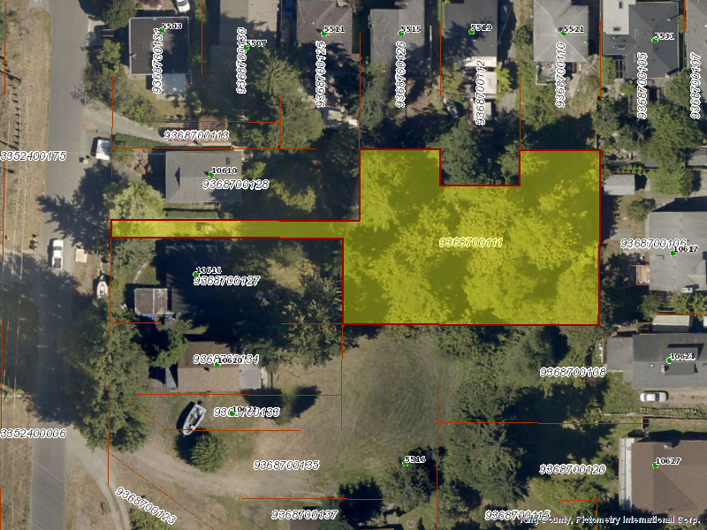

**History:**

This property was acquired at a public sale of real property held on the 13th Day of May, 1977, pursuant to a real property local improvement assessment by judgement entered in Superior Court in the County of King on December 22, 1976. Subsequently the City has created two separate tax parcels to reflect the discontinuous nature of the property. Parcel number

963870-0111 will be treated as a buildable lot.

**Documents:**

Seattle City Council Ordinance: 95943, 7/14/1967, AN ORDINANCE providing for the improvement of South Spencer Street from Beacon Avenue South to 28th Avenue South; and certain other streets and avenues.

King County Superior Court cause action SC 710272, 5/9/1972

**Acquisition Deeds:** 5/15/1979, 197912310591, Fee simple deed transfer, From Seattle City Treasure to Seattle Executive Services Department, King County Recording Number 197912310591.

**Acquisition Fund Source:**  General Fund.

**Jurisdictional Department’s estimated market value:**

FAS determines value based upon the following factors:

* 1. Previous one year vacant property sales within 2 miles of the subject property;
  2. Adjacent King County assessed land value on per square foot basis;
  3. Either positive or negative factors for unique topography, property dimensions and shape;
  4. Evaluation of potential added development capacity if combined with adjacent property;
  5. Perpetual easements or reservations for slope easements or native vegetation.

A review has been conducted as summarized below:

* 1. The value of separate vacant building lots range from $6.00 to $15 per square foot;
  2. The average of the adjacent lots is valued by the King County Assessor at $11.80 per square foot;
  3. The property has a narrow ingress/egress which may limit further subdivision;
  4. It is unknown if the property is buildable due the existing environmental restrictions;
  5. The property contains steep slopes and vegetation which may affect the ability to build on the property.

Based on the above factors FAS values the property at $11.80 per square foot. The value range of the property is $65,000- $70,000

**Destination of funds upon sale:** A portion to the Facility Services Sub-fund for expenses relating to sale of property, the remainder to general fund.

**Current easements, covenants and restrictions:** None of record

**Recommended easements, covenants and restrictions upon Transfer:** None

**Potential problems with property and possible measures to mitigate their recurrence:** Existing trees on the site may reduce location of building foot print. The location of utilities serving the property is unknown. The access has been used by the adjacent property owner for multiple years buyer may need to negotiate an easement for continued shared use

**Neighborhood:** Rainier Beach and Skyway

**Legal Description:**

**PMA 4522**

Ptn of Lot 2, Block 3, and Ptn of Lots 1 and 2, block 4, Vol. 13 Pg. 38 tax/Map Id9s)

Tax Account No.: 936270-0111-08

**Adjacent Property Owners:**

9368700126 9368700106

Edmon, Elisha E. Tran Truong Nhat

5515 S. Bangor St. 10617 56th Ave S.

Seattle, WA 98178 Seattle, WA 98178

Land value: $71,000, $12.60 per sf Land value: $78,000, $10.83 per sf

9368700112 9368700108

Cormier, Donald J. Nguyen, Hoa

5519 S. Bangor St. 10621 56th Ave S.

Seattle, WA 98178 Seattle, WA 98178

Land value: $66,000, $12.22 per sf Land Value: $88,000, $8.49 per sf

9368700110 9368700127

Winstead, Raymond H. Jr. + Makeb Bushnell, Roger G.

5521 S. Bangor St. 10616 55th Ave S.

Seattle, WA 98178 Seattle, WA 98178

Land Value: 64,000, $14.50 per sf Land Value: $74,000, $11.76 per sf

9368700135 9368700128

Pratt, Mitchell-Roberta Murray, Jacqueline

5516 S. Hazel St. 10610 55th Ave S.

Seattle, WA 98178 Seattle, WA 98178

Land value: $89,000, $7.26 per sf. Land value $71,000, $12.6 per sf

936870 0131 9368700130

Morningstar, Sarah Emerald Real Estate Solution

5503 S Bangor St 5507 S Bangor St

Seattle, WA 98178 Seattle, WA 98178

Land value: $56,000, $12.93 per sf Land value: $ 67,000, $14.50 per sf

September 18, 2015

**CITY OF SEATTLE**

**EXCESS PROPERTY RESPONSE FORM**

**Excess Parcel at 10612 55th Ave S. (PMA 4522)**

|  |
| --- |
| * **Seattle Public Utilities** * **Seattle Department of Transportation** * **Seattle Office of Housing** * **Seattle City Light** * **Seattle Parks and Recreation** * **Seattle Department of Neighborhoods** * **Seattle Department of Planning and Development** * **Seattle Office of Economic Development** * _____________________________________   _________ We have no interest in this property.  _________ We are interested in acquiring the property or jurisdiction over it. A completed ***Excess Property Proposed Use Form*** is attached to this response.  _________ We have facilities on the property or access rights through or across the property as described below (add additional sheets as necessary):  _________ We need facilities on the property or access rights through or across the property as described below (add additional sheets as necessary):  _________ We have identified the following plans, policies, objectives, limitations or other factors as found in adopted or proposed City plans and policies that may affect the Reuse or Disposition of the property (add additional sheets as necessary): |
| **___________________________ _______________________ ______________**  **Reviewer Department Date** |
| **EXCESS PROPERTY PROPOSED USE FORM** | |
| _______________________________________ (department/agency ) wants to acquire property rights over all or a portion of:  Excess Parcel at 10612 55th Ave S. (PMA 4522) | |
| **PROPOSED USE:** Describe the proposed use for the property, including information on potential improvements, users, tenure, impact on neighborhood such as parking, traffic volumes. (Attach additional pages as necessary). | |
| **EST. IMPLEMENTATION DATE:** _________ **EST. COST** : _________________  **EXPECTED TERM OF USE**: ______________ **FUND SOURCE(S)**: _____________________  Are funds appropriated? € YES € NO If no, when will funds be appropriated? ________ | |
| **BENEFITS TO THE CITY OF SEATTLE FROM THIS PROPOSAL:** | |
| **SUPPORTING POLICIES**. List the adopted plans and policies (itemize specific sections in major documents) which support, or are implemented by, this proposed use. | |
| **CONTACT PERSON:_____________________________** **PHONE:___________________**  ________________________________________________ **Date** : ___________________  **Director or designee** | |